Test Application: https://demo.nopcommerce.com/
Module: User Registration
Date: July 19, 2025

Test Case 1: Valid User Registration

Test Case ID: 01

Test Case Title: Verify successful user registration with valid data
Test Priority: High

Pre-conditions:
- Navigate to https://demo.nopcommerce.com/
- User is not already registered with the email being used

Test Steps:
- Click on "Register" link in the top navigation
- Select gender (Male/Female)
- Enter valid first name (e.g., "Sarah")
- Enter valid last name (e.g., "Morrison")
- Enter valid email address (e.g., "sarah.morrison@example.com")
- Enter valid password (minimum 6 characters, e.g., "Password123")
- Enter the same password in "Confirm password" field
- Click "Register" button

Expected Results:
- Registration should be successful
- User should be redirected to registration success page
- Success message should be displayed
- User should be automatically logged in

Actual Results:
- User registered successfully

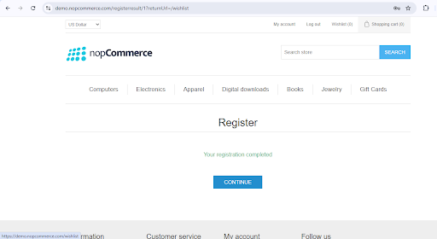

Status: PASS

Test Case 2: Registration with Invalid Email Format

Test Case ID: 02
Test Priority: High

Test Case Title: Verify registration fails with invalid email format

Pre-conditions:
- Navigate to https://demo.nopcommerce.com/
- Click on "Register" link

Test Steps:
- Select gender (Male/Female)
- Enter valid first name (e.g., "Sarah")
- Enter valid last name (e.g., "Morrison")
- Enter invalid email format (e.g., "invalid-email", "test@", "@domain.com")
- Enter valid password (e.g., "Password123")
- Enter the same password in "Confirm password" field
- Click "Register" button

Expected Results:
- Registration should fail
- Error message should be displayed for invalid email format
- User should remain on registration page
- Form should not be submitted

Actual Results:
- “Please enter a valid email address” validation message displayed
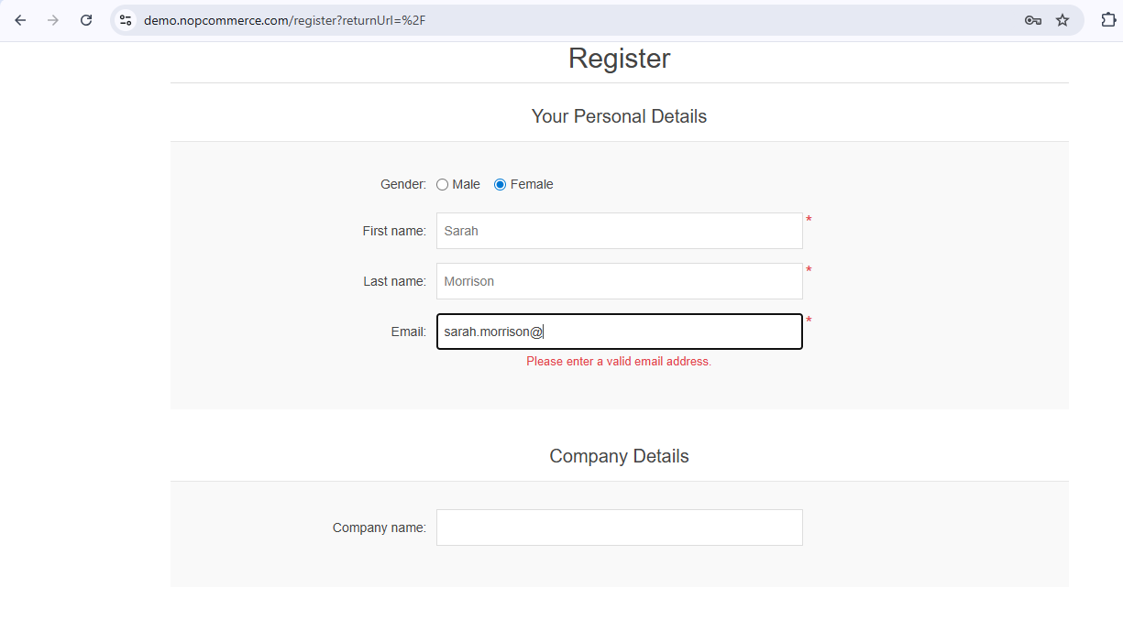

Status: PASS

Test Case 3: Registration with Password Mismatch

Test Case ID: 03
Test Priority: High

Test Case Title: Verify registration fails when passwords don't match

Pre-conditions:
- Navigate to https://demo.nopcommerce.com/
- Click on "Register" link

Test Steps:
- Select gender (Male/Female)
- Enter valid first name (e.g., "Sarah")
- Enter valid last name (e.g., "Morrison")
- Enter valid email address (e.g., "sarah.morrison@example.com")
- Enter password (e.g., "Password123")
- Enter different password in "Confirm password" field (e.g., "Password456")
- Click "Register" button

Expected Results:
- Registration should fail
- Error message should be displayed indicating password mismatch
- User should remain on registration page
- Form should not be submitted

Actual Results:
- “The password and confirmation password do not match” validation message displayed

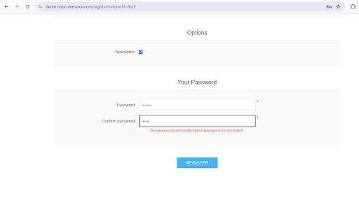

Status: PASS

Test Case 4: Register with an already registered email

Test Case ID: 04
Test Priority: High

Test Case Title: Verify registration fails with already registered email

Pre-conditions:
- An account already exists with the email being used for testing

Test Steps:
- Navigate to registration page
- Fill all fields with valid data
- Use an email that is already registered
- Click "Register" button

Expected Results:
- Registration should fail
- Error message should indicate email already exists
- User should remain on registration page

Actual Results:
- “The specified email already exist” error message showed
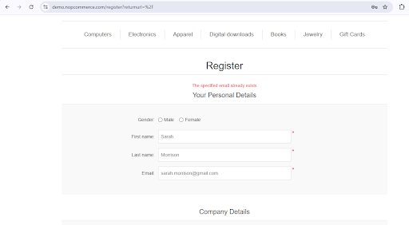

Status: PASS

Test Case 5 : Empty Registration Form Submission

Test Case ID: 03
Test Case Title: Verify validation messages for empty form submission
Test Priority: Medium

Test Steps:

Navigate to "Register" page

Click "Register" without entering any details

Expected Results:

Required field validation messages should be displayed for all mandatory fields

Actual Results:

Validation messages shown as expected

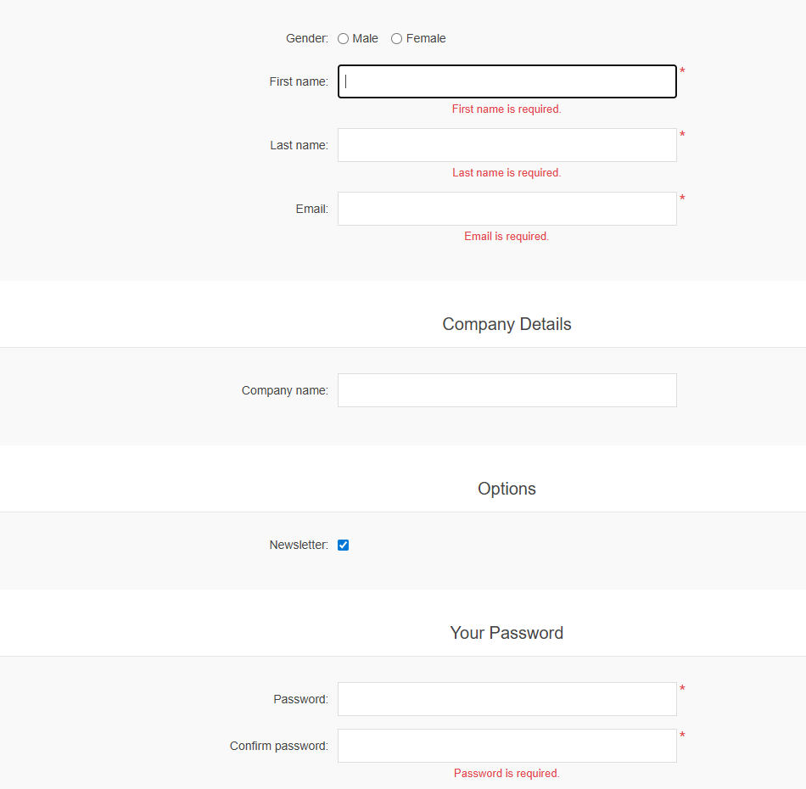
Status: PASS

